**Case Study: Basic Scheduling**

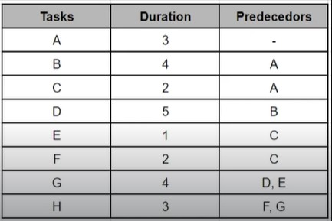

**When is the delivery date?**

* All times in the day

**Which tasks could be delayed without delaying the schedule?**

* All tasks can’t be delayed except A, G, and H